**BDSP Screenshots**

1. Import sentiment_analysis.csv file into ‘Test’ database and ‘sentiment’ collections for MongoDB

1. Checking the data loaded correctly in the ‘test’ database within MongoDB shell

1. Moving sentiment_analysis.csv file into Lab04 directory for apache spark processing

1. Starting up dfs.sh and yarn.sh for cluster mode

1. Ensuring appropriate ipynb file and csv file are in HDFS for processing activity

1. Launching pyspark

1. Confirming yarn mode is running from within pyspark

1. Reading in and displaying csv file, shortened file to stay within VM capacity

1. Counting number of lines in file



1. Processing text data and then displaying word counts in descending order

Initial dataframe

Tokenized words

Most frequent words and their respective counts

1. Export data out to dfs

1. Copying sentiment_pyspark.csv to local file

1. Merged the split dataframe into one file ‘merged_sentiment_pyspark.csv’

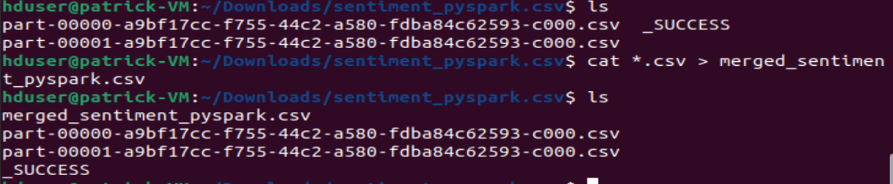

1. Imported merged_sentiment_pyspark.csv file to MongoDB

1. Successfully imported, initial query to confirm

